

National Textile University
Department of Computer Science
Subject: Operating System

Submitted to: Sir Nasir

Submitted by: Maha

Reg. number: 23-NTU-CS-1170
Docker Lab 03
Semester:5th

Docker Lab 03

Multi-Container Applications, Docker Compose & Best Practices

Step 1: Project Structure
c
d

~
mkdir

guest
-
b
ook
c
d

guest
-
b
ook
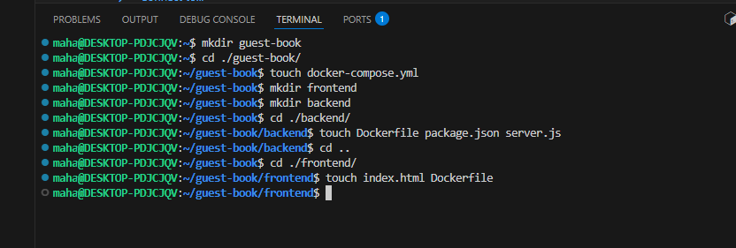
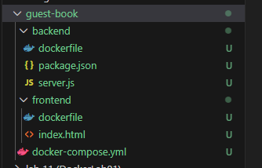

Create the following structure:
guest
-
b
ook
/
├──

do
c
ker
-
c
ompose
.
yml
├──

bac
kend
/
│

├──

D
o
c
kerfile
│

├──

p
ac
k
a
ge
.
json
│

└──

server
.
js
└──

frontend
/
├──

D
o
c
kerfile
└──

index
.
html

Codes:
- Backend
- DockerFile

FROM node:lts-alpine3.23
WORKDIR /app
COPY package*.json ./
RUN npm install
COPY server.js .
EXPOSE 3000
CMD ["npm", "start"]

- Package.json
{
"name": "guest-book-backend",
"version": "1.0.0",
"type": "module",
"scripts": {
"start": "node server.js"
},
"dependencies": {
"express": "^4.18.2",
"mongoose": "^8.0.0",
"cors": "^2.8.5"
}
}

- Server.js
import express from 'express';
import mongoose from 'mongoose';
import cors from 'cors';
const app = express();
const PORT = 3000;
app.use(cors());
app.use(express.json());
// MongoDB connection URL
const MONGO_URL = process.env.MONGO_URL ||
'mongodb://mongodb:27017/guestbook';
// Define Mongoose Schema
const messageSchema = new mongoose.Schema({
name: {
type: String,
required: true
},
message: {
type: String,
required: true
},
timestamp: {
type: Date,
default: Date.now
}
});
// Create Mongoose Model
const Message = mongoose.model('Message', messageSchema);
// Connect to MongoDB
async function connectDB() {
try {
await mongoose.connect(MONGO_URL);
console.log('Connected to MongoDB with Mongoose');
} catch (error) {
console.error('MongoDB connection error:', error);
process.exit(1);
}
}
// Get all messages
app.get('/api/messages', async (req, res) => {
try {
const messages = await Message.find()
.sort({ timestamp:-1 })
.limit(10);
res.json(messages);
} catch (error) {
res.status(500).json({ error: error.message });
}
});
// Post a new message
app.post('/api/messages', async (req, res) => {
try {
const { name, message } = req.body;
const newMessage = new Message({
name,
message
});
await newMessage.save();
res.status(201).json(newMessage);
} catch (error) {
res.status(400).json({ error: error.message });
}
});
// Start server
connectDB().then(() => {
app.listen(PORT, () => {
console.log(`Server running on port ${PORT}`);
});
});

- Frontend
- Dockerfile
FROM nginx:trixie
COPY index.html /usr/share/nginx/html/
EXPOSE 80

- Index.html
<!DOCTYPE html>
<html lang="en">

<head>
<meta charset="UTF-8">
<meta name="viewport" content="width=device-width, initial-scale=1.0">
<title>Guest Book</title>
<style>
body {
font-family: Arial, sans-serif;
background: linear-gradient(135deg, #667eea 0%, #764ba2 100%);
min-height: 100vh;
padding: 20px;
margin: 0;
}

.container {
max-width: 600px;
margin: 40px auto;
background: white;
padding: 30px;
border-radius: 10px;
box-shadow: 0 10px 40px rgba(0, 0, 0, 0.3);
}

h1 {
color: #333;
text-align: center;
}

.subtitle {
text-align: center;
color: #666;
margin-bottom: 30px;
}

.form-group {
margin-bottom: 15px;
}

input,
textarea {
width: 100%;
padding: 10px;
border: 2px solid #e0e0e0;
border-radius: 5px;
font-size: 16px;
box-sizing: border-box;
}

button {
background: #667eea;
color: white;
border: none;
padding: 12px 30px;
font-size: 16px;
border-radius: 5px;
cursor: pointer;
width: 100%;
}

button:hover {
background: #5568d3;
}

.messages {
margin-top: 30px;
}

.message {
background: #f8f9fa;
padding: 15px;
border-radius: 5px;
margin-bottom: 10px;
}

.message-name {
font-weight: bold;
color: #667eea;
}

.message-time {
font-size: 12px;
color: #999;
margin-top: 5px;
}
</style>

</head>

<body>
<div class="container">
<h1>Guest Book</h1>
<p class="subtitle">Powered by Docker Compose</p>

<div class="form-group">
<input type="text" id="nameInput" placeholder="Your name">
</div>

<div class="form-group">
<textarea id="messageInput" placeholder="Leave a message..." rows="3"></textarea>
</div>

<button onclick="addMessage()">Sign Guest Book</button>

<div class="messages" id="messagesList">
<p style="text-align: center; color: #999;">Loading messages...</p>
</div>
</div>

<script>
const API_URL = 'http://localhost:3000/api/messages';

async function loadMessages() {
const response = await fetch(API_URL);
const messages = await response.json();
const messagesList = document.getElementById('messagesList');

if (messages.length === 0) {
messagesList.innerHTML = '<p style="text-align: center; color: #999;">No messages yet. Be the first!</p>';
return;
}

messagesList.innerHTML = messages.map(msg => `
<div class="message">
<div class="message-name">${escapeHtml(msg.name)}</div>
<div>${escapeHtml(msg.message)}</div>
<div class="message-time">${new Date(msg.timestamp).toLocaleString()}</div>
</div>
`).join('');
}

async function addMessage() {
const name = document.getElementById('nameInput').value.trim();
const message = document.getElementById('messageInput').value.trim();

if (!name || !message) {
alert('Please enter both name and message');
return;
}

await fetch(API_URL, {
method: 'POST',
headers: { 'Content-Type': 'application/json' },
body: JSON.stringify({ name, message })
});

document.getElementById('nameInput').value = '';
document.getElementById('messageInput').value = '';
loadMessages();
}

function escapeHtml(text) {
const div = document.createElement('div');
div.textContent = text;
return div.innerHTML;
}

loadMessages();
</script>
</body>

</html>

Docker-compose.yml:
- Create networks to facilitate communication between frontend, backend and database.
- The requirement is that frontend must not be able to call the database container.
- Don't forget to create named volume with the same name you've used in docker-compose.yml
services:
# MongoDB Database
mongodb:
image: mongo:7-jammy
container_name: guestbook-db
networks:
- backend_net
volumes:
- mongo_data:/data/db

# Backend API
api:
build: ./backend
container_name: guestbook-api
environment:
- MONGO_URL=mongodb://mongodb:27017
ports:
- "3000:3000"
depends_on:
- mongodb
networks:
- backend_net
- frontend_net

# Frontend
web:
build: ./frontend
container_name: guestbook-web
ports:
- "8080:80"
depends_on:
- api
networks:
- frontend_net

networks:
backend_net:
driver: bridge
frontend_net:
driver: bridge

volumes:
mongo_data:

Output of both image building commands e.g "docker build -t frontend ."
Commands:
- cd backend
- docker build -t backend .
- cd ..
- cd frontend
- docker build -t frontend .
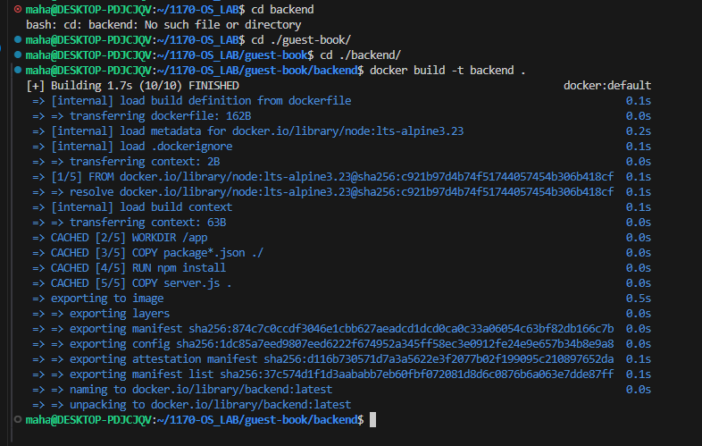
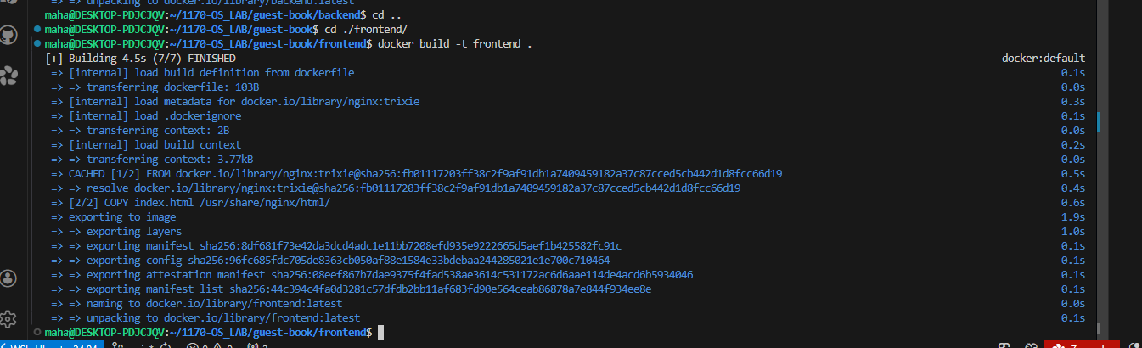
Pulling mango db:
Command:
- Docker pull mango:7-jammy
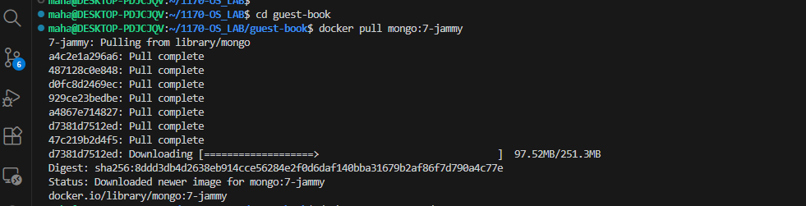

Running the Application
Command:
- docker compose up -d
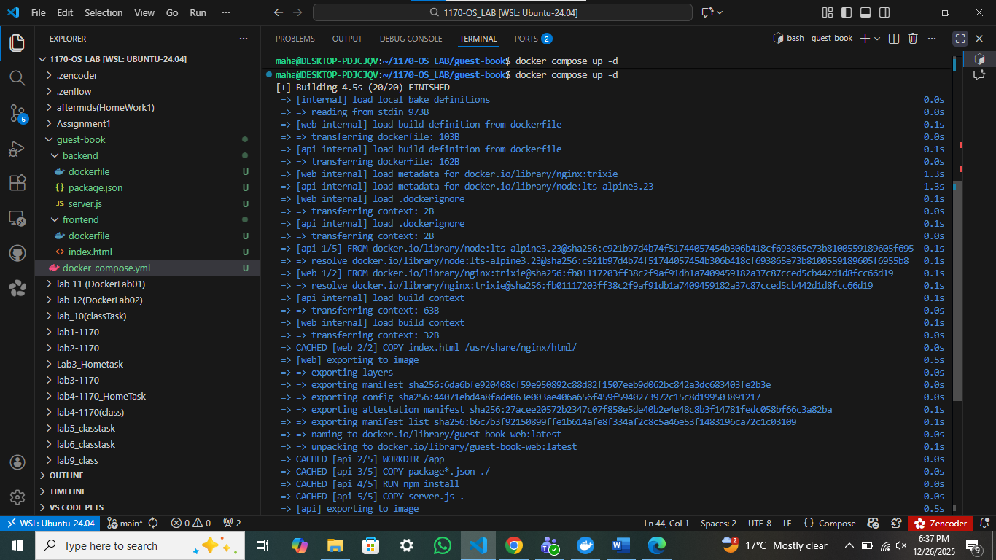
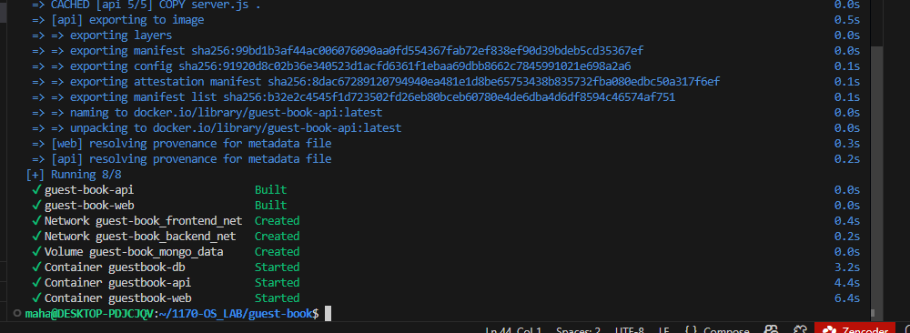
Open your browser:
Visit: http://localhost:8080 Enter your name and a message Messages persist in MongoDB!
Webpage:
